Put your logo in this area

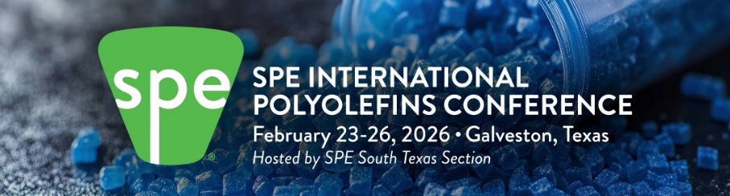



Inspiring and Enabling Innovation for Polyolefins

We are proud to be a SPONSOR at the 2026 SPE International Polyolefins Conference at the Galveston Convention Center in Texas on February 23-26, 2026. We look forward to seeing you at the conference. For those of you attending the conference virtually, you can contact us through our virtual sponsor booth.
The Convention Center overlooks the Beach with hotels in close proximity.

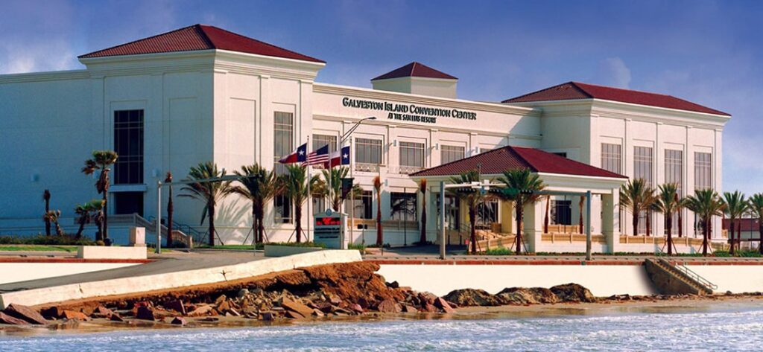

The Conference will feature:
Monday afternoon Tutorial
130+ presentations
60+ Exhibitor Booths
15+ Sponsors
Expected attendance >1,000
Two Networking Receptions (Mon PM, Tues PM)
Student Poster Competition

Click Here for Information and to Register

For more information about the Conference, go to
www.polyolefinsconference.org or watch the short video
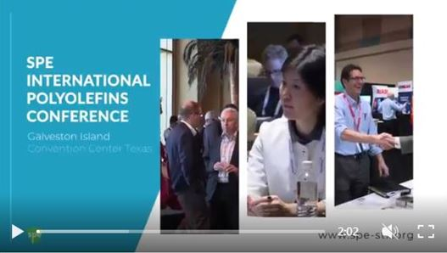

Join the excitement. We look forward to seeing you at the 2026 SPE International Polyolefins Conference in Galveston, TX

Possible graphics:

