Template for 2026 Sponsor to create a post on their own LinkedIn page

XXXXX is excited to be a Sponsor at the 2026 SPE International Polyolefins Conference. We hope to see you there. www.polyolefinsconference.org
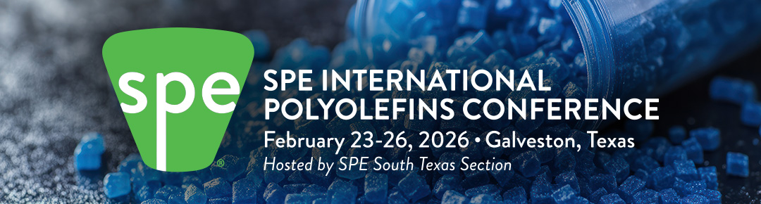

Possible graphics
