Template for 2026 Exhibitors to create a post on their own LinkedIn page

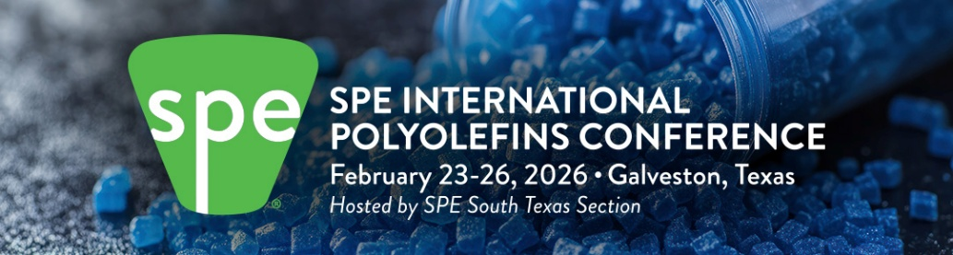
XXXXX is excited to be an Exhibitor at the 2026 SPE International Polyolefins Conference. We are in booth XXX. We hope to see you there to talk with us. www.polyolefinsconference.org
Your logo

Possible graphics

