Put your logo in this area

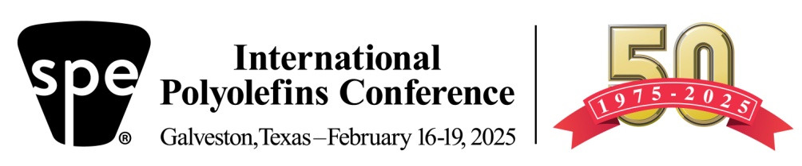

|  |  |  |  |
| --- | --- | --- | --- |
| |  | | --- | |  | | |  | | --- | | https://imgssl.constantcontact.com/letters/images/sys/S.gif | | |

|  |  |
| --- | --- |
| |  | | --- | | **Inspiring and Enabling Innovation for Polyolefins** | |

We are proud to be a **SPONSOR** at the **2025 SPE International Polyolefins Conference** at the [Galveston Convention Center](https://www.visitgalveston.com/meetings-groups/galveston-island-cc/?gclid=CjwKCAiAv_KMBhAzEiwAs-rX1L3_2iDdWvgpBNgde0gaRpxs0sRj-T2fLHXfE2sk0D021cYm1XD63RoCkSsQAvD_BwE) in Texas on **February 16-19, 2025** to celebrate the 50th year anniversary of the Conference. We forward to seeing you at the conference. For those of you attending the conference virtually, you can contact us through our virtual sponsor booth.

The Convention Center overlooks the Beach with hotels in close proximity.

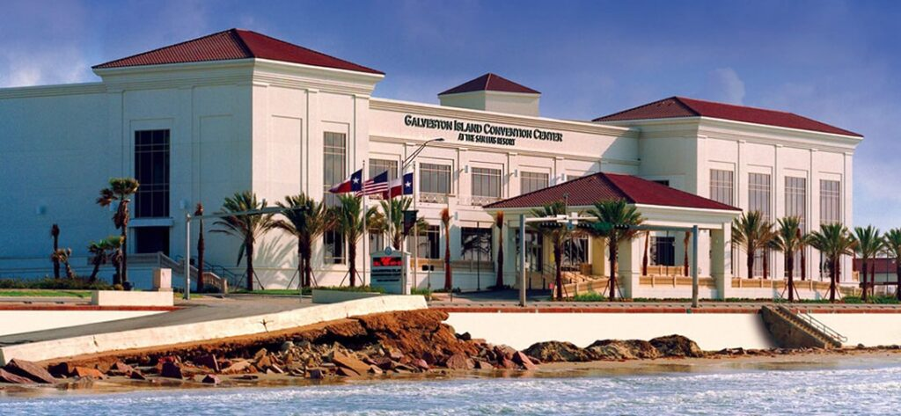

The Conference will feature:

Sunday afternoon Tutorial   
130+ presentations  
60+ Exhibitor Booths (through Wed noon)  
15+ Sponsors  
Expected attendance >1,000   
 Two Networking Receptions (Sun PM, Mon PM)  
Special Wednesday session to commemorate 50 years  
Student Poster Competition

[Click Here for Information and to Register](https://site.pheedloop.com/event/PO2025/home)

For more information about the Conference, go to

[www.polyolefinsconference.org](http://www.polyolefinsconference.org) or watch the short video

[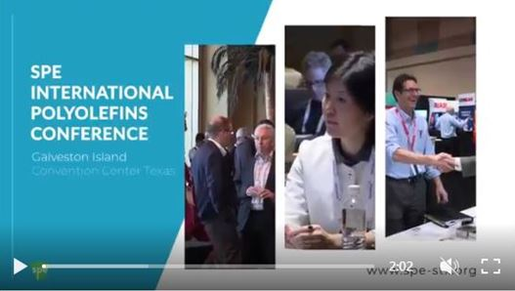](https://spe-stx.org/videos/SPEGALVESTON2022Final3.mp4)

Join the excitement. We look forward to seeing you at the 2025 SPE International Polyolefins Conference in Galveston, TX

Possible graphics:

