Template for 2025 Sponsor to create a post on their own LinkedIn page

**XXXXX**  is excited to be a **Sponsor** at the 2025 SPE International Polyolefins Conference. We hope to see you there and celebrate the 50th year anniversary of the conference. [www.polyolefinsconference.org](http://www.polyolefinsconference.org)

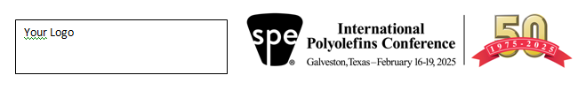

Possible graphics

