Template for Sponsors to create a post on their own LinkedIn page

Below is an example of a LinkedIn Post for a Sponsor on their own LinkedIn page

Chevron Phillips Chemical Company is proud to be a GOLD SPONSOR at the 2024 SPE International Polyolefins Conference. We hope to see you there. www.PolyolefinsConference.org

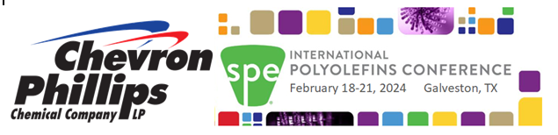

Customize the above post with your own logo/text, the sponsorship level, and apply the hyperlink ( http://www.PolyolefinsConference.org ) to the customized graphic. To create the graphic with your logo for your LinkedIn Post
- Use the graphic on the next page
- Move the logo from the graphic and insert your logo. You will have to size your logo properly, right click on your logo, go to “text wrap” and then choose “Tight” or “Through” you can easily move the logo around.
- You will then have to open the Microsoft “Snipping Tool” (it is a program in Windows under Windows Accessories). Click the “New” button in the Snipping Tool Program, and move the cursor to create a box around the graphic to copy it. Make sure the width is at least twice as long as the height to show up in LinkedIn properly. Save the graphic as a jpg on the hard drive of your computer in an appropriate file by clicking on “file” and then “save as” in the Snipping Tool program.

