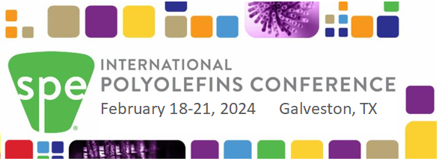
Put your logo in this area

Inspiring and Enabling Innovation for Polyolefins

Xxxxxx is proud to be a xxxxx Sponsor at the 2024 SPE International Polyolefins Conference at the Galveston Convention Center in Texas on February 18-21, 2024. The conference is promising to be an exciting time for all with:
Sunday afternoon Tutorial
131 presentations
60+ Exhibitor Booths (through Wed noon)
15+ Sponsors
Expected attendance >1,000
Two Networking Receptions (Sun PM, Mon PM)
Student Poster Competition
Click here to see the Program. Click here to see the Speakers.
The Convention Center (the white building) overlooks the Beach with hotels in close proximity.
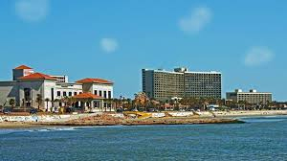

For more information about the Conference, go to
www.polyolefinsconference.org or watch the short video
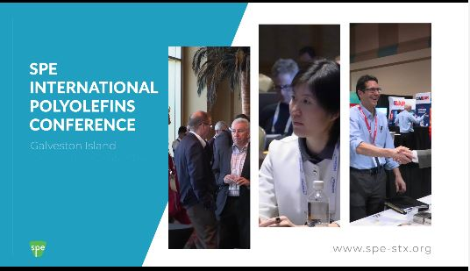

We look forward to seeing you at the 2024 SPE International Polyolefins Conference in Galveston, TX

