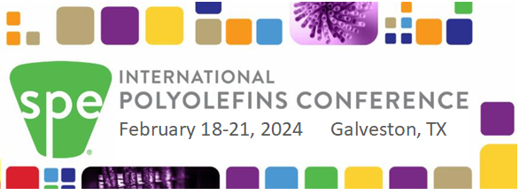
Put your logo in this area

Inspiring and Enabling Innovation for Polyolefins

We are excited to be Exhibiting at the 2024 SPE International Polyolefins Conference at the Galveston Convention Center in Texas on February 18-21, 2024. We will be in Booth xxxxx in the Exhibit Hall so please stop by to talk to us about your needs and our portfolio of products to meet your needs. For those of you attending the conference virtually, you can also access our virtual booth.
The Convention Center (the white building) overlooks the Beach with hotels in close proximity.
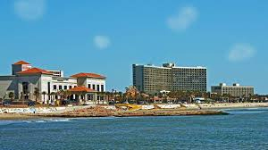

The Conference will feature:
Sunday afternoon Tutorial
131 presentations
60+ Exhibitor Booths (through Wed noon)
15+ Sponsors
Expected attendance >1,000
Two Networking Receptions (Sun PM, Mon PM)
Student Poster Competition
Click here to see the Program. Click here to see the Speakers.

Click Here to Register as an Attendee (in-person or virtual)

For more information about the Conference, go to
www.polyolefinsconference.org or watch the short video
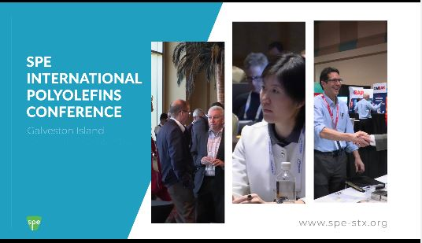

Join the excitement. We look forward to seeing you at the 2024 SPE International Polyolefins Conference in Galveston, TX

